Home

User Manual

DensiPaper Rich Text Image Editor

Version: 1.0.0.13

Contents

Overview 3

Installation 3

Download Link 3

Setup 3

Operation 7

Preferences 7

Profiles 8

How Layout Works 9

# Overview

The Rich Text Image Editor application provides a simple but instinctively usable tool for generating perfectly formatted images using the familiar Rich Text Editor features then uploading the images to the DensiPaper portal and sending them to one or more devices.

The RTE allows using any languages and fonts, including Bar Code Fonts, which are installed on the host operating system and can accommodate a background image in any image format which recognized by the operating system. However colour pictures can suffer serious degradation when converted to Black and White monochrome so we recommend converting them to monochrome prior to application, probably use dithering to improve quality.

There are known limitation of the RTE, most notably there is no random insertion point, so the position of a text depends on the preceding characters and therefore if a font size changes in any preceding part that could change the layout.

The application is truly WYSIWYG, which means that although the RTE can automatically extend upon entering more text than the display size allows the generated image will be only the actually visible part of the RT Box, hence no scroll bars.

We recommend to use the application to communicate with the portal so the generated image can be uploaded and sent, however, images generated can be saved on the host and use them later.

# Installation

## Download Link

Please download installation kit from <https://github.com/densipaper/rich_text_image_editor/archive/master.zip>

Alternatively use

<https://portal.densipaper.com/static/resources/RichTexImageEditor-V1.0.0.13..zip>

## Setup

Open the zip.

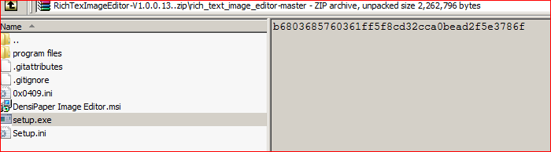

Run Setup.exe

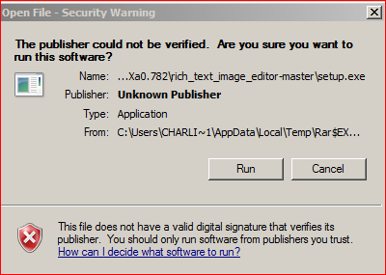

Click on Run.

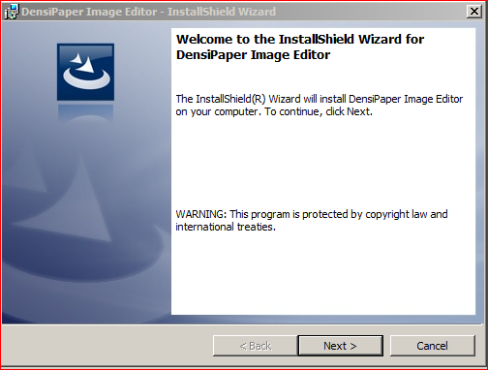

Click on Next

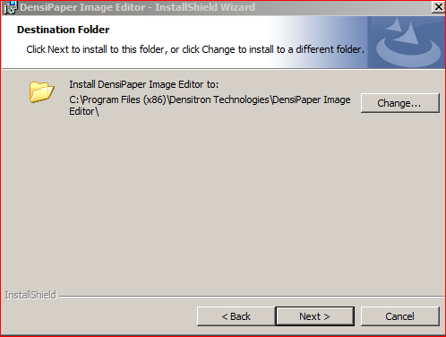

Accept Default Directory or Change to a new one clicking on Change Button then click on Next

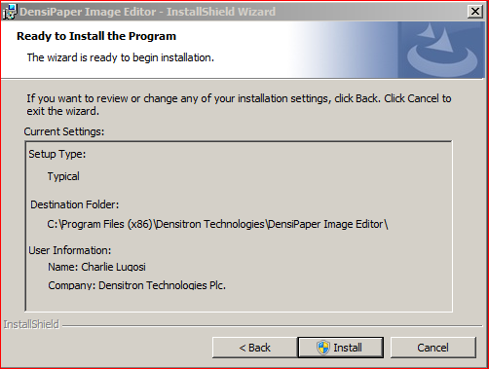

Click on Install

When installation is successful click on Finish

The new installed item appears in the Menu

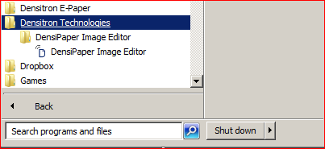

Note: In Win 8… search for DensiPaper Image Editor

# Operation

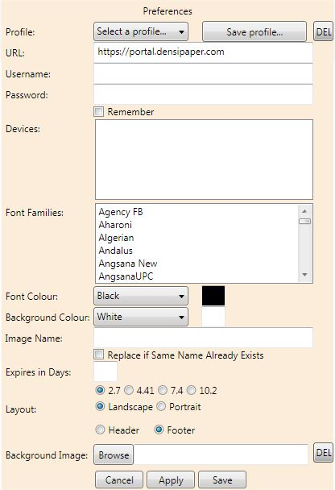Preferences

Upon opening the DensiPaper Image Editor, you will be presented with a preferences table (if the preferences table hasn’t appeared for you, you can find it by going to File > Preferences).

Initially, you have to sign into the DensiPaper portal. This will give you access to your Devices, and allow you to send images to them. The URL, as seen in the image to the left is: ‘https://portal.densipaper.com’. This will connect your account directly to the DensiPaper portal. Following this, you will be requested to give your username and password details, to then give you access to your allocated devices.

Then you have to select the device(s) you wish to send the image to. (Note: if you wish to select multiple devices, make sure they’re of the same size, otherwise the image will only be sent to the device fitting the device you’re making the image for).

After gaining access to, and selecting your devices, you have the opportunity to select which font you would like to use. Then you can set the colour of the font, and the colour of the background, you’re given the option of picking between black and white only, because the images you’re working with only support a monochrome colour scheme.

The image name is simply what you would like the files name to be uploaded under, and then you can select how many days the image will be displayed on the device before it expires (or is overwritten by another image). This section can be left blank.

Background image allows you to select an image (bmp, jpeg or png), which will be displayed as the background image of your document. You can write over the top of your background image, and even lay images over it. If you wish to remove the background image, you may have to restart the image editor, and start it as a new file.

Cancel – will remove any of the changes you have made, and then close the preferences table.

Apply – will apply any changes you have made, and then close the preferences table.

Save – will save any changes you have made.

When you’ve finished with your image, and you would like to upload it to your device(s), you can find the upload option in File > Upload.

## Profiles

A newly added feature of the DensiPaper Image Editor, is the use of profiles. Profiles allow you to save the state of any preference table, and then load it in at a later point. This saves you time as the user, meaning you don’t have to setup the preferences every time you use the application, instead you just select the profile you would like to use. To create a profile, choose *‘Save Profile…’* at the top of the preferences table and give your profile a name; Press *‘Save’* or the *Enter* button when you’ve given it a name, and then that profile will be ready for use next time you open your preferences.

If you wish to delete any preferences you’ve created, select the profile and press *‘Del’*. This will remove the profile file and the option from the list.

You can also export preferences for the application to use if it is located on a different machine, and import them accordingly. To do so, go to File > Import/Export depending on what you intend to do:

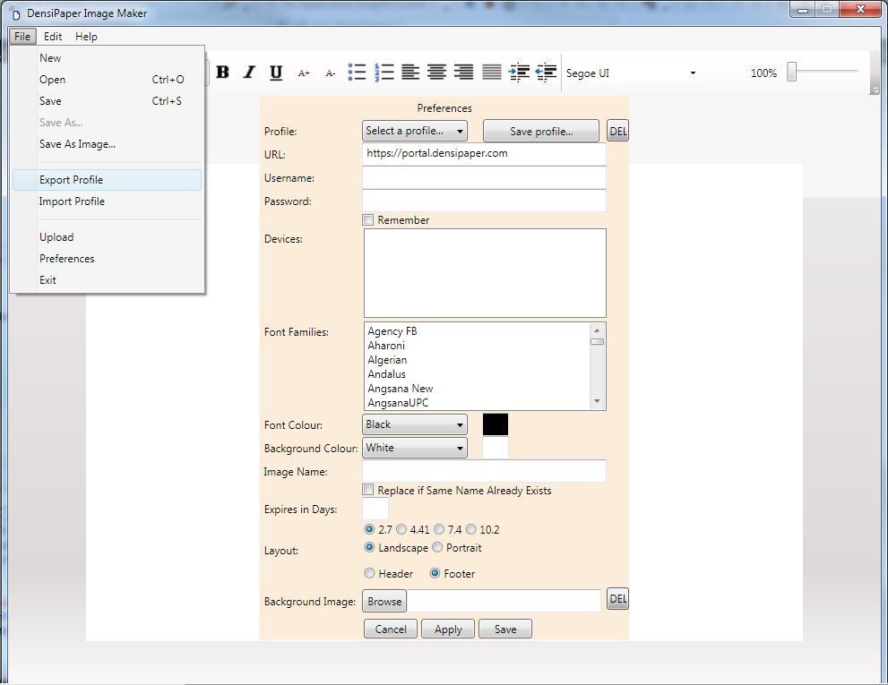

This will open a window that allows you to select a location to export the profile to. Selecting Import does the same, the purpose of it differs in the fact that this allows you to select a location of an existing profile on your machine (.txt file), and will then import it and upload the state to your preferences table. This will also create a profile entry, so the next time you use the application you will be able to select this as a profile without having to import it again.

## How Layout Works

Looking at the layout we see that we have 4 size options (in reference to device size), 2 layout options, and 2 orientation options.

The 2 orientation options refer to what direction the device is facing, and therefore what direction your image will be made in. The orientation of your device can be confirmed by checking the mounting brackets at the back of the device, so by default, whatever way the device hangs, is its default ‘Header’ orientation. This means that if you have a native portrait device, and you want to display a landscape image, you would simply choose landscape, followed by either ‘Header’, or ‘Footer’ depending on how you want your image oriented.

How this applies to landscape devices:

Important: Make sure the size of your device matches the size you selected in the preferences table.

Landscape

Footer

Landscape

Footer

Landscape

Header

Portrait

Footer

Portrait

Header

How this applies to portrait devices:

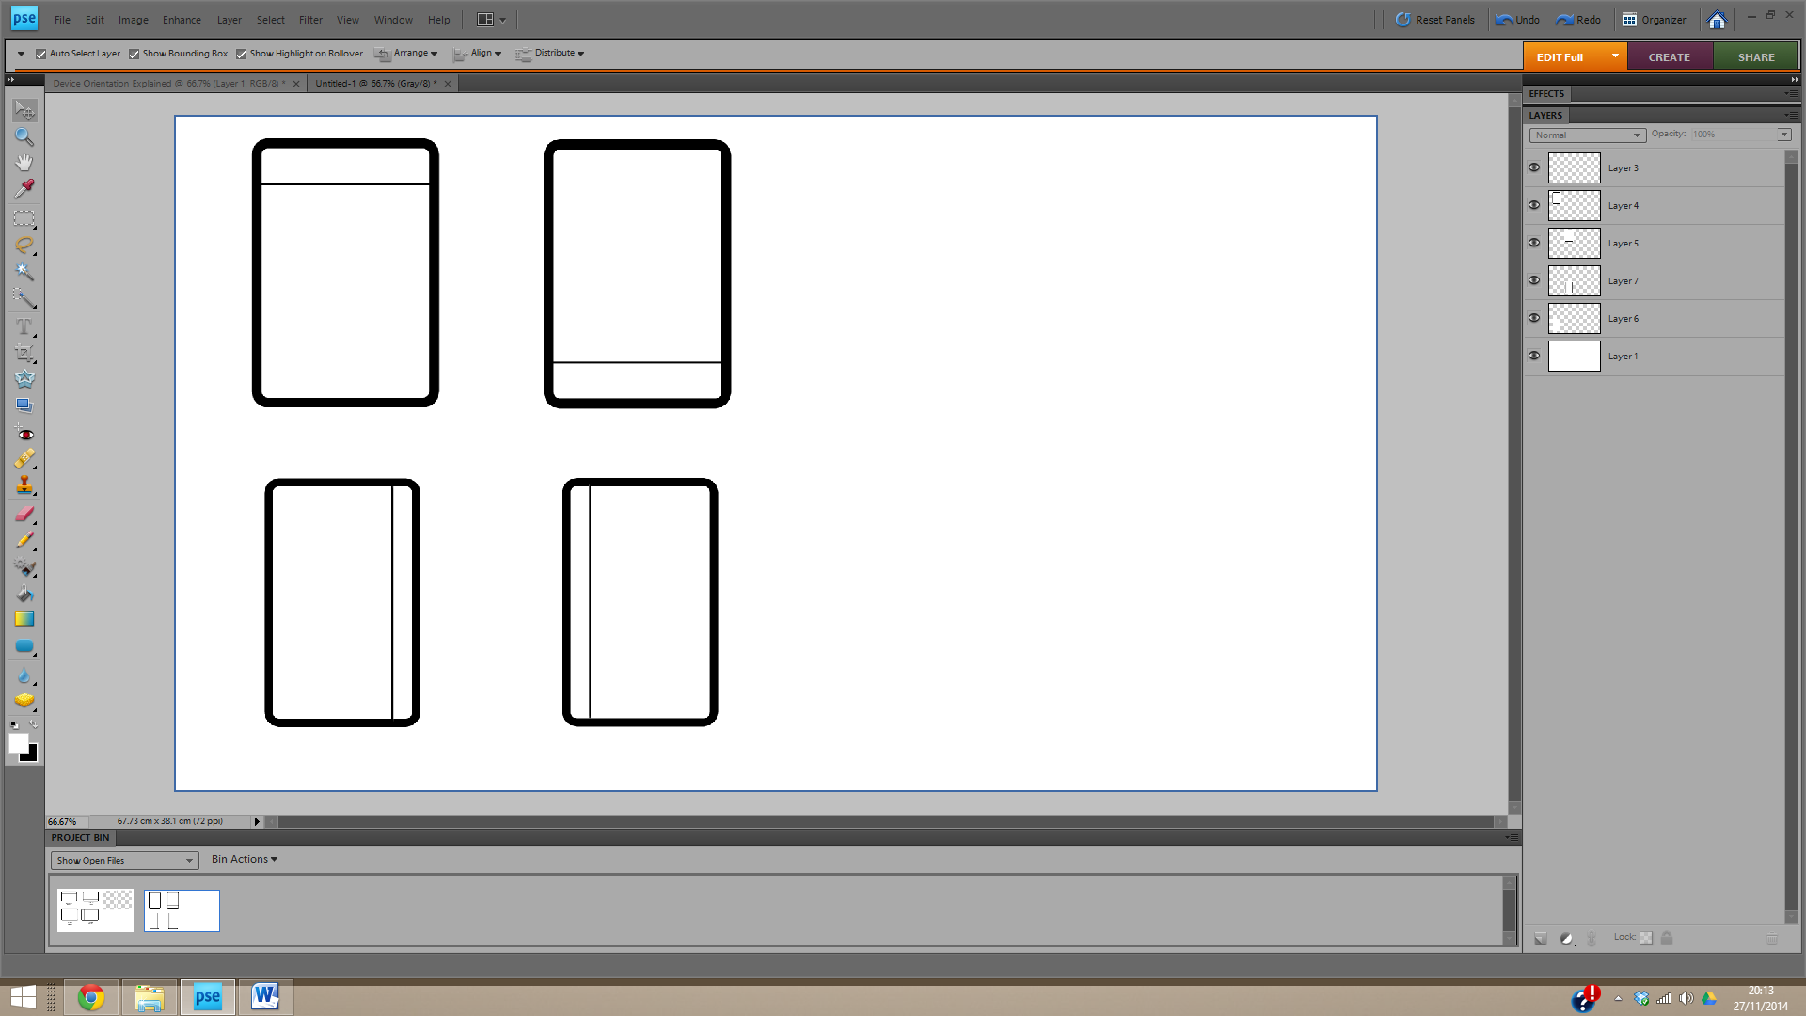

Landscape

Footer

Landscape

Header

Portrait

Footer

Portrait

Header